ECE 188 Final Project

**ECE 188: Computer Vision, Spring 2023**

**Project: Vision-Based 3D Reconstruction and Recognition System**

**Christopher Demos, 405692773**

# Stage 1: Noise Removal

| *Noise / Blur Type* | *PSNR (Average)* | *SSIM (Average)* | *Benchmark* |
| --- | --- | --- | --- |
| Gaussian Blur | 22.11 | 0.75 | 20.5 / 0.65 |
| Motion Blur | 20.1 | 0.67 | 21.5 / 0.7 |
| Salt and Pepper | 26.77 | 0.92 | 26.5 / 0.9 |
| Gaussian Noise | 20.63 | 0.61 | 19.5 / 0.6 |
| Speckle Noise | 23.29 | 0.77 | 20.0 / 0.65 |

### Gaussian Blur

For the gaussian blur images, I used the unsharp_mask filter from skimage as well as a wiener filter. The unsharp mask technique involves creating a sharpened version of an image by subtracting a blurred version of the image from the original image. This process enhances the high-frequency components, such as edges and fine details, while reducing the low-frequency components, such as smooth regions and noise.

I used the wiener filter from skimage restoration. The wiener filter is used for image deconvolution. It estimates the original, unblurred image by minimizing the mean squared error between the observed degraded image and the estimated image. The filter takes into account both the blurring and the noise characteristics to produce a deblurred result. I used a point spread function of size 5.

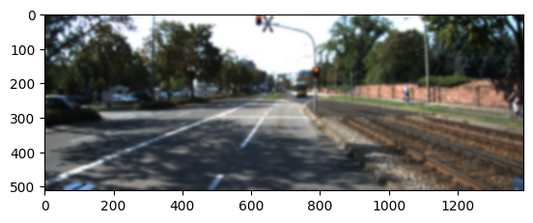

*Image 1: Gaussian Blur Noisy Image*

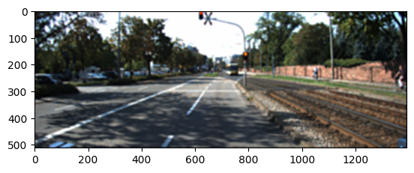

*Image 2: Gaussian Blur Filtered Image*

### Motion Blur

For motion blur, I didn't quite reach the benchmark. The final method I tried using was an unsharp_mask combined with a wiener filter. For the wiener filter I used a point spread function which was a column of ones divided by the sum of the ones. I then rotated this matrix by various different angles to see which angle resulted in the best performance. This method was aimed at reconstructing the original effects of the motion blur, which the wiener filter would perform a deconvolution on. I used a kernel of size 3 and angle of 160 degrees.

I also tried other implementations of the wiener filter and also the Richardson-Lucy Deconvolution, but could not reach the benchmark. It is possible that I did not reach the benchmark because my search over the angles or kernels was not a fine enough search. I could also try other implementations of the wiener filter (some implementations include a balance of denoising and deblurring). I could also try adaptive filtering. Instead of using a fixed PSF, adaptive filters can adjust the PSF based on the image. For example there are edge-preserving filters that adapt to the image structure. Adaptive filters can better handle regions with varying blur characteristics or deal with images containing different types of blurs. However, it was mentioned in class that the motion blur was obtained from a simple rotated averaging kernel, so an adaptive filter should not be necessary here.

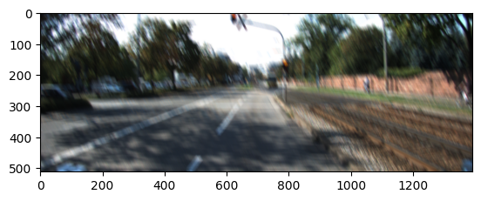

*Image 3: Motion Blur Noisy Image*

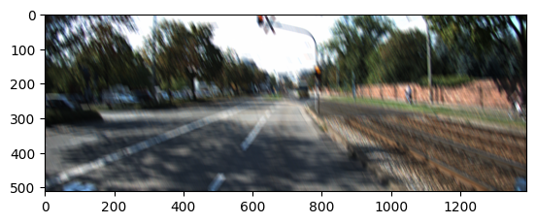

*Image 4: Motion Blur Filtered Image*

### Salt and Pepper

For salt and pepper noise I used a median filter with kernel size 3. The median filter works well because the salt and pepper noise can contain extreme values such as 0 or 255, which can skew a mean filter, but is eliminated with the median filter.

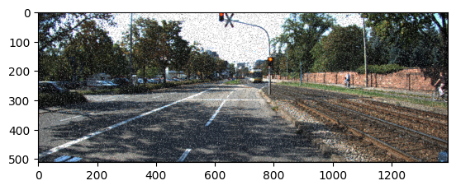

*Image 5: Salt and Pepper Noisy Image*

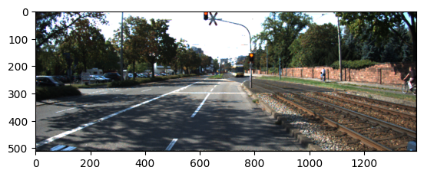

*Image 6: Salt and Pepper Filtered Image*

### Gaussian Noise

For gaussian noise, I used a median filter with a kernel size of 9. The median filter works well for gaussian noise because it maintains edges while eliminating noise. A mean filter could also work well, though the results were better for a median filter.

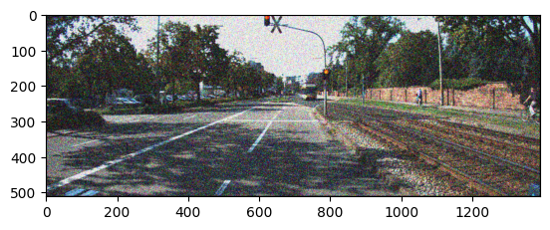

*Image 7: Gaussian Noise Noisy Image*

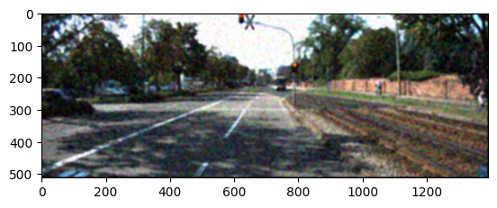

*Image 8: Gaussian Noise Filtered Image*

### Speckle Noise

Speckle noise is a type of noise that appears as granular interference in digital images or signals. For speckle noise I used a median filter of kernel size 3. The median filter replaces each pixel with the median value of the surrounding pixels.

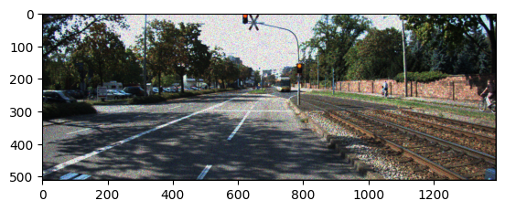

*Image 9: Speckle Noise Noisy Image*

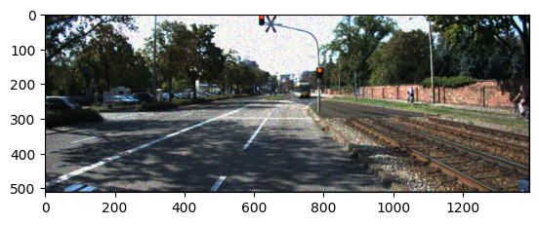

*Image 10: Speckle Noise Filtered Image*

# Stage 2:

## Part 1: Rectification

For this section we are to unwarp an image using rectification. The method I used for this section was first to grayscale and then find the keypoints using detect-and-compute from OpenCV. This function performs both keypoint detection and feature extraction using the Scale-Invariant Feature Transform algorithm. The keypoints are invariant to scale, rotation, and illumination changes, and are selected based on their local extrema in the difference-of-Gaussian space, which highlights regions with significant changes in intensity.

Then I used OpenCV’s BFMatcher, which does feature matching using the Brute-Force matching algorithm. Feature matching finds correspondences between keypoints and their descriptors in different images. The algorithm computes the distance between descriptors and returns the best matches based on the distance values.

Then I selected the matches that had a distance of less than 0.85. Using these matches I found the homography matrix, then used it to perform the rectification.

The results were as follows:

Average PSNR: 32.44 (benchmark is 30.0)

Average SSIM: 0.959 (benchmark is 0.90)

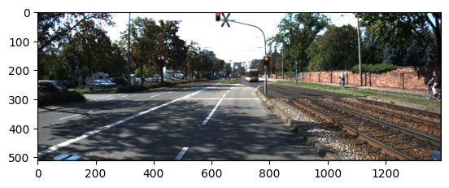

*Image 11: Original Image*

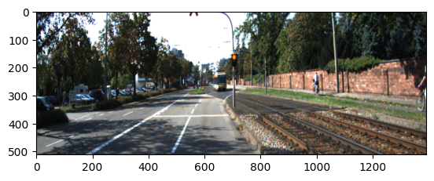

*Image 12: Warped Image*

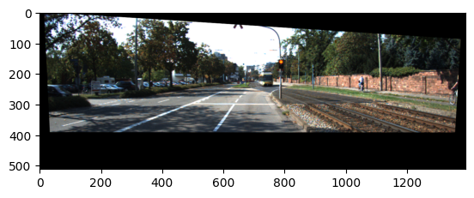

*Image 13: Rectified Image*

## Part 2: Stereo Matching

Stereo Matching is a technique used to extract depth information from a pair of stereo images. It aims to find the correspondence or matching points between the left and right images, enabling the estimation of the 3D structure of the scene.

Traditional block matching involves comparing small patches in the left and right images to find the best matching block. Common measures for matching criterion include sum of absolute differences, sum of squared differences, and normalized cross-correlation. The disparity value for the selected block is determined by finding the candidate block in the right image with the lowest matching cost. The disparity represents the horizontal shift needed to align the best match with the corresponding pixel in the left image. The process is repeated for each pixel in the left image, resulting in a disparity map where each pixel's intensity represents its estimated disparity value.

Block matching may encounter challenges in textureless or repetitive regions, occlusions, and noise, leading to inaccuracies or artifacts in the disparity map. To address these issues, more advanced techniques such as semi-global matching (SGBM), graph cuts, or machine learning approaches can be employed.

For this section I used OpenCV’s Semi-Global Block Matching (SGBM) algorithm. It estimates the disparity map between a pair of stereo images by comparing pixel intensities across different blocks or windows.The main advantage of SGBM over basic block matching is its ability to consider the global information while minimizing the disparity cost.

For each image I found the optimum block size, max disparity, speckle Window, and uniqueness ratio. The block size is the size of the block or window used for matching. Uniqueness ratio determines how unique the best match must be. Speckle window size is the maximum size of a speckle region that is considered valid. A speckle is a small area in the disparity map that exhibits inconsistency or noise. Max disparity determines the maximum possible difference in pixel position that the algorithm considers during the matching process.

Result:

Average RMSE = 3.18 pixels

| **Image Filename** | **Block Size** | **Max Disparity** | **Speckle Win** | **Uniqueness Ratio** | **RMSE** |
| --- | --- | --- | --- | --- | --- |
| 000000_10.png | 47 | 256 | 100 | 15 | 1.64 |
| 000001_10.png | 5 | 80 | 300 | 15 | 2.73 |
| 000002_10.png | 47 | 176 | 200 | 10 | 2.34 |
| 000003_10.png | 7 | 96 | 300 | 15 | 5.09 |
| 000004_10.png | 47 | 160 | 200 | 10 | 4.12 |

I saw that image 000003_10.png had the worst result RMSE of 5.09. From the image below we see that the road is a textureless region that the algorithm may struggle with.

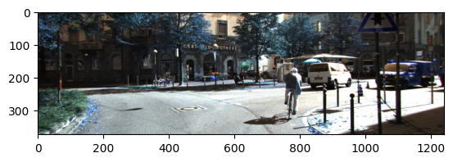

*Image 14: Left Image for* 000003_10.png

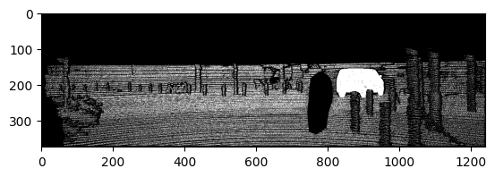

*Image 15: True Disparity Image for* 000003_10.png

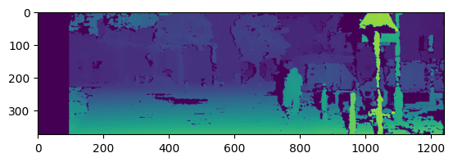

*Image 16: Calculated Disparity*

# Stage 3:

### VoxelNet Model Architecture

I tested the VoxelNet Architecture. I followed the Github repository for Voxelnet (2), as well as the paper, “VoxelNet: End-toEnd Learning for Point Cloud Based 3D Object Detection,” (1).

One of the advantages of VoxelNet is its ability to perform end-to-end learning, meaning it can learn directly from raw point cloud data and output accurate 3D bounding boxes without relying on intermediate steps or manual feature engineering. This end-to-end approach simplifies the detection pipeline and enhances the model's overall efficiency. The term "voxel" is derived from "volume element" and represents a small three-dimensional unit or volume element in a 3D space. A voxel grid is a data structure that represents a 3D space divided into a grid of voxels.

The VoxelNet architecture consists of three main blocks: the Feature Learning Network (FLN), Convolutional Middle Layers, and Region Proposal Network (RPN). The FLN extracts descriptive features from the voxel grid by processing individual point clouds within each voxel and calculating the statistics or summarizing the features.

The Convolutional Middle Layers convert voxel features into dense 4D feature maps and reduce the size of the feature map. This process helps capture local patterns and relationships within the voxel data. After convolution, batch normalization is applied to normalize the output feature maps. It adjusts the mean and standard deviation, which helps stabilize the learning process. Then the middle layers use ReLU as its activation function.

By transforming the voxel features into dense 4D feature maps, the convolutional middle layer enables the network to learn hierarchical representations of the input data. These representations capture increasingly complex patterns and contribute to accurate object detection and localization in the 3D environment.

The RPN consists of fully convolutional layers and is responsible for generating accurate 3D bounding boxes.

I followed the GitHub implementation from (2). Since some of the libraries are deprecated, I needed to update some of the files: crop.py, training_helper.py, test_helper.py and utils.py, which are included in my submission. The jupyter notebook included in my submission is based on the GitHub implementation (2), and includes blocks for preprocessing the data, as well as training the data. To run the notebook it is necessary to import the GitHub repository and update the files mentioned above. It is also necessary to import the “kitti_eval” GitHub repository (3) for the calculation of precision-recall plots.

### Results

I trained the model for eight epochs until the training loss decreased to around 0.07, and the validation loss decreased to 0.26. From the images below it is clear that there is much more improvement to be made. The purple boxes are the true values for the bounding box locations, and the light blue are the predicted bounding boxes. The predicted results have several boxes in the wrong places, though for Image 17 and 18 the clearly visible car in the center is bounded well. The results shown on the Github repo (2) are from 30 epochs of training. These results show that with more time and compute power, this model can obtain accurate bounding box predictions.

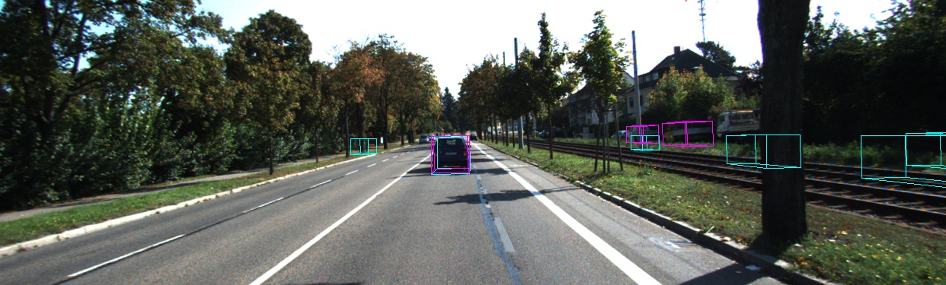

*Image 17: Predicted Bounding Boxes for 000219.bin*

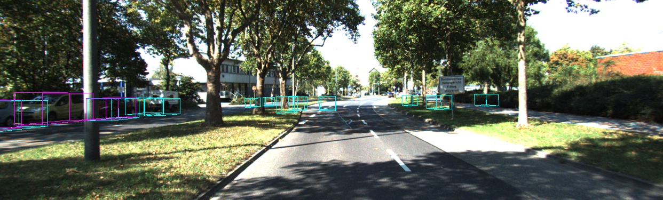

*Image 18: Predicted Bounding Boxes for 000256.bin*

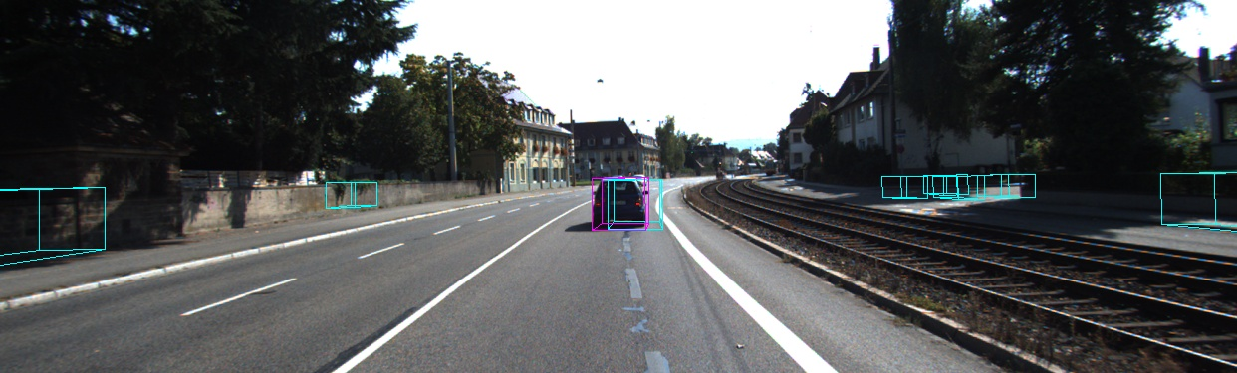

*Image 19: Predicted Bounding Boxes for 001341.bin*

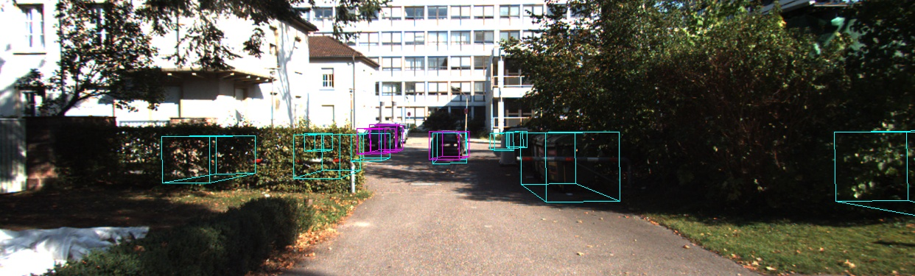

*Image 20: Predicted Bounding Boxes for 004179.bin*

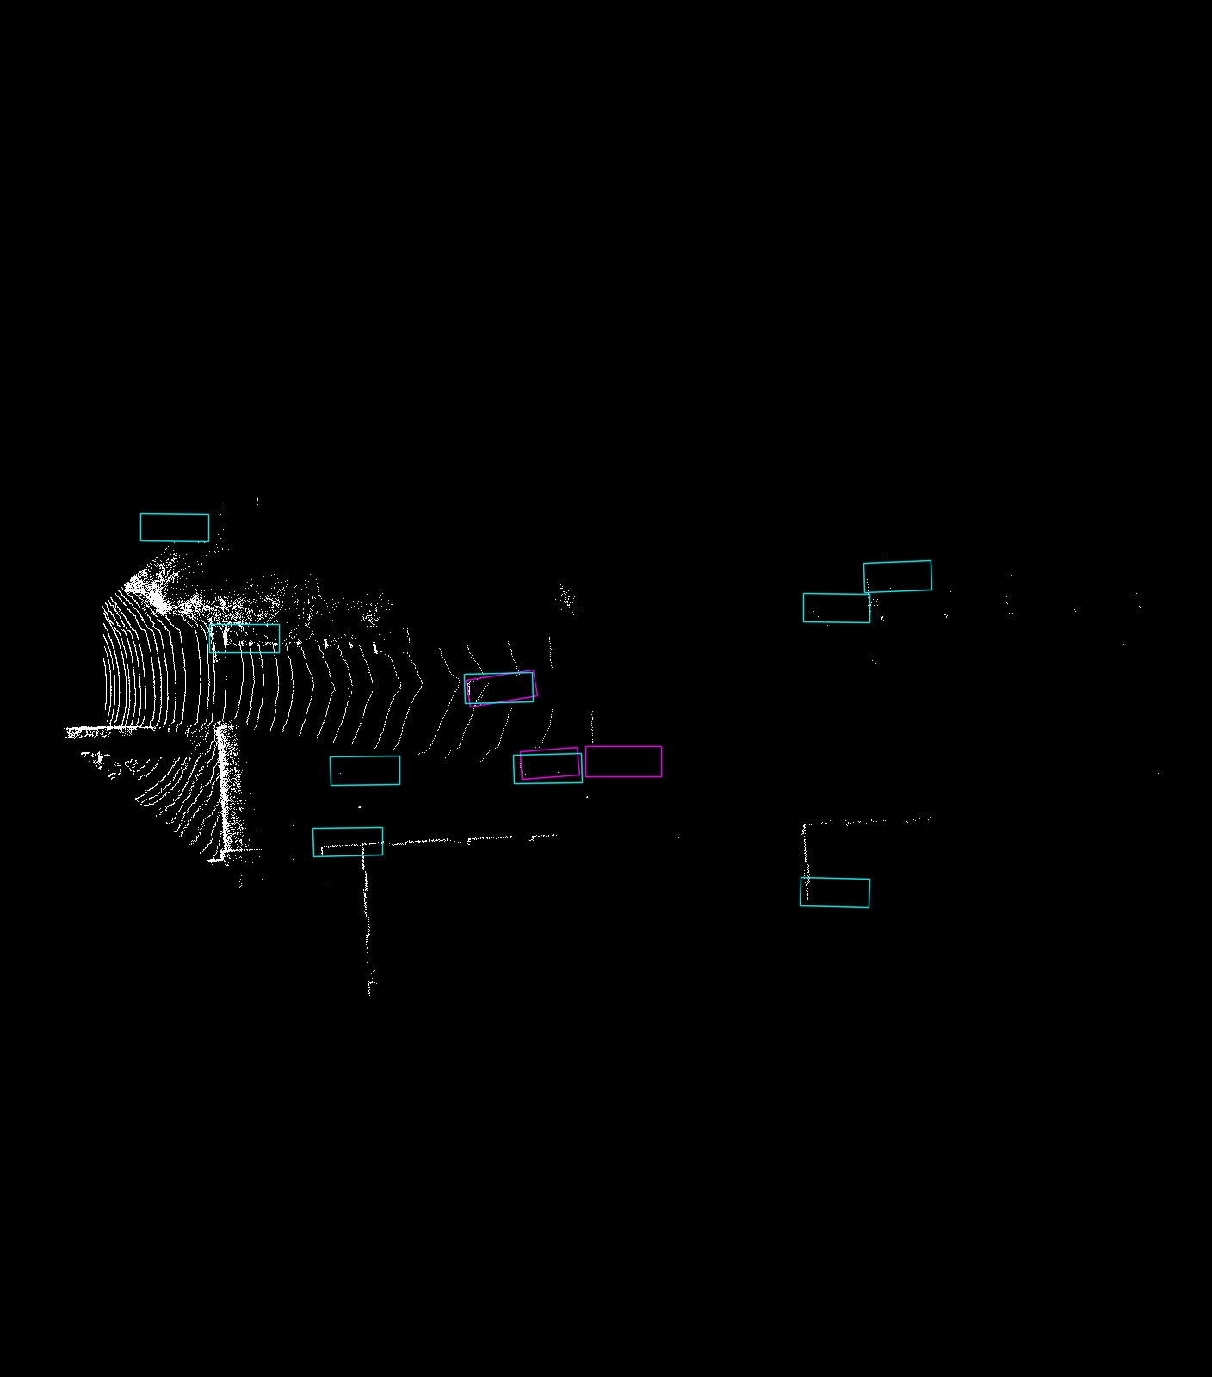

*Image 21: Above view of Prediction for 004179.bin*

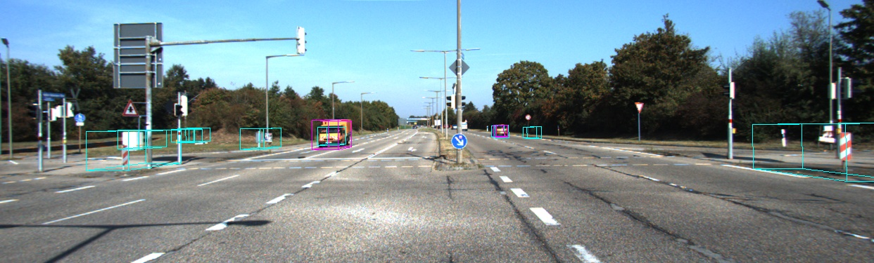

*Image 22: Predicted Bounding Boxes for 004413.bin*

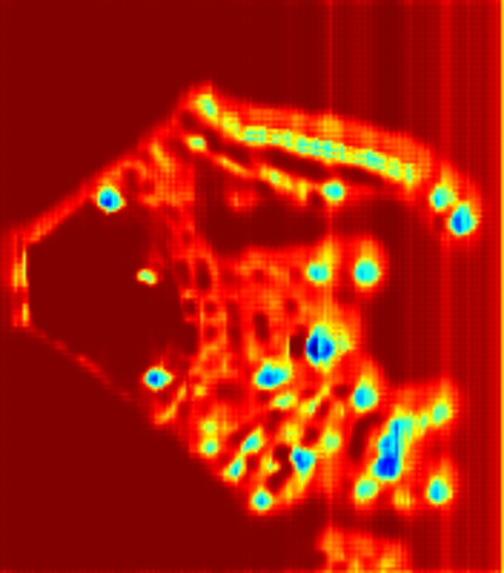

*Image 23: Above heat map for 004413.bin*

From the plots of loss, I saw that the loss quickly declines after a few hundred iterations, and doesn’t see much improvement after that. From the plot of negative loss for training classification it is more evident that progress is being made across iterations. This is representative of the class Imbalance; since there is more opportunity for negative classification (areas without bounding boxes), it has led to a clearer negative classification loss trend. Since there is a limited number of bounding boxes, there is more variability in the classification loss. Something I could try for future improvement is tuning the hyper parameters such as the batch size or learning rate. Or I could try adjusting the optimizer from adam to adagrad or SGD. Though, adam is generally preferred when dealing with large datasets, and SGD requires manual tuning of the learning rate and may converge more slowly compared to adaptive algorithms like Adam.

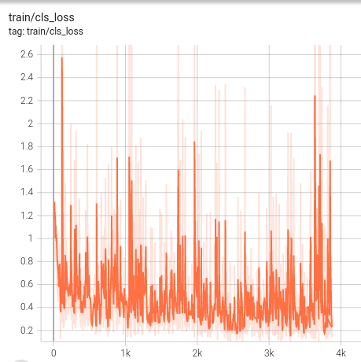

*Image 24: Training loss over number of iterations*

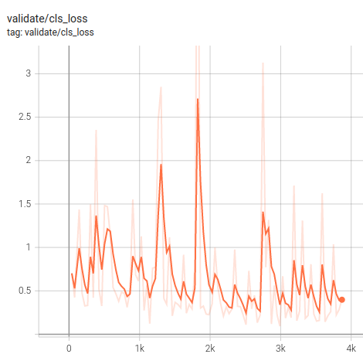

*Image 25: Validation loss over number of iterations*

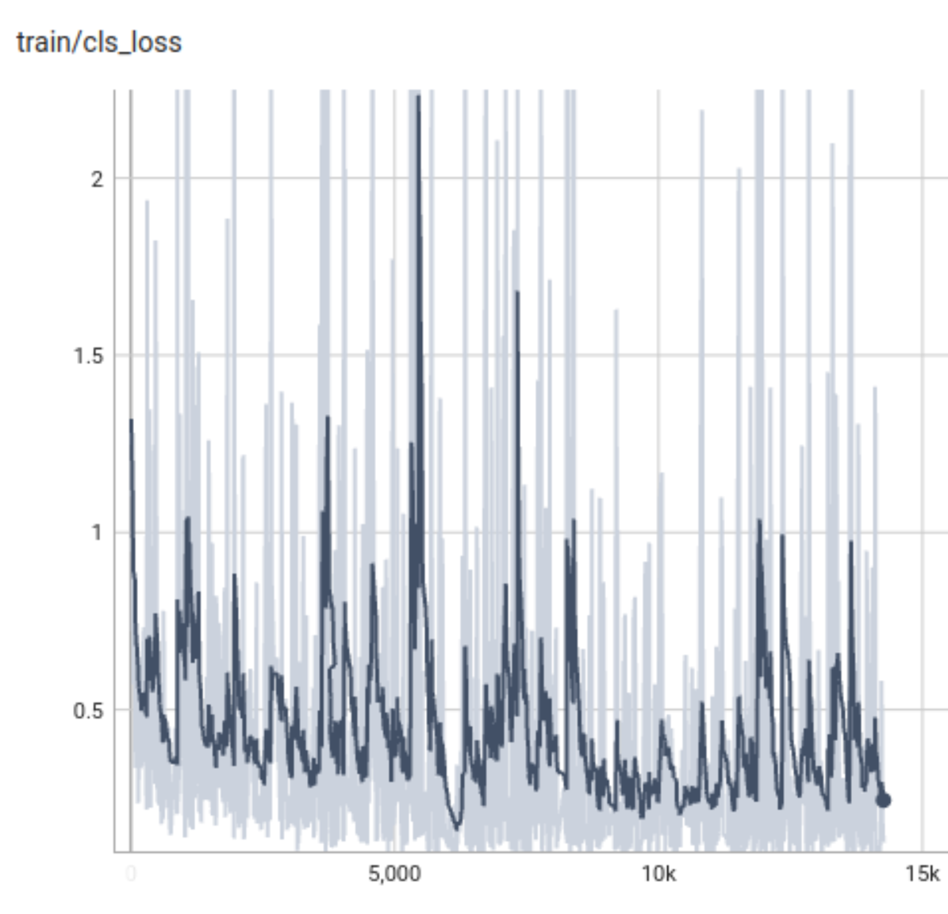

*Image 26: Training classification loss over 14,000 iterations*

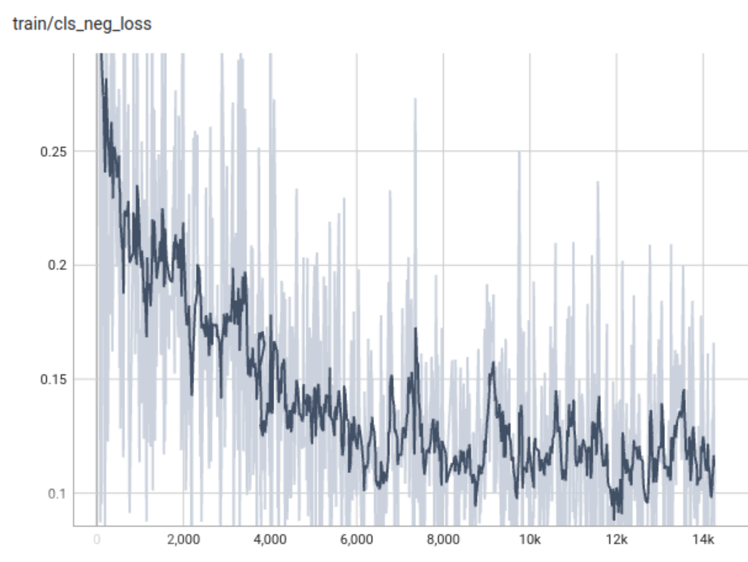

*Image 27: Training classification negative loss over 14,000 iterations*

From the precision-recall plot in Image 28, one can see the correctly predicted bounding boxes (true positives) out of all the predicted bounding boxes (true positives + false positives), for the precision of the model. From the images it is clear that the model is making many false positives, so the precision is low. We also see the number of correctly predicted bounding boxes out of all actual bounding boxes, as the recall. Low recall means more false negatives, so there were cars that were not given bounding boxes. We see that for the moderate and hard KITTI criteria, recall was worse. For moderate and hard criteria the bounding box minimum height, occlusion and truncation requirements are more stringent.

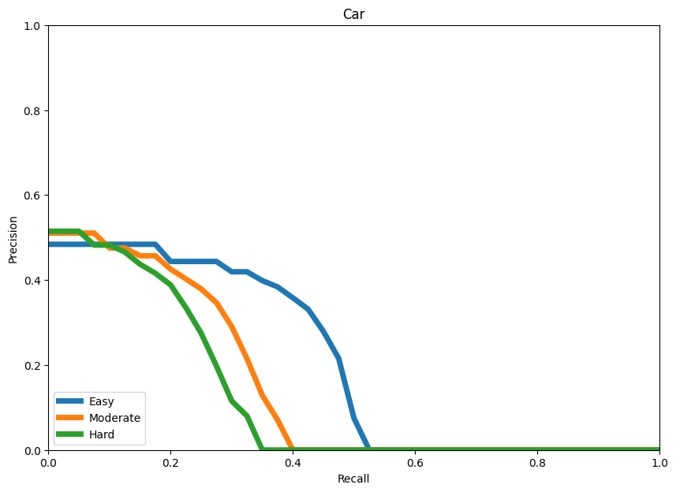

*Image 28: Car detection Precision-Recall Plot from Kitti_Eval data*

*Image*

# References

1. Y. Zhou and O. Tuzel, "VoxelNet: End-to-End Learning for Point Cloud Based 3D Object Detection," *2018 IEEE/CVF Conference on Computer Vision and Pattern Recognition*, Salt Lake City, UT, USA, 2018, pp. 4490-4499, doi: 10.1109/CVPR.2018.00472.
2. Gopalakrishna Adusumilli, Voxelnet, “3D objects detections in LIDAR point clouds for autonomous driving”, (2020), GitHub repository, <https://github.com/gkadusumilli/Voxelnet>
3. Bo Li and Xiaozhi Chen, “kitti_eval”, GitHub repository, (2019), <https://github.com/prclibo/kitti_eval/tree/master>
4. Andreas Geiger and Philip Lenz and Raquel Urtasun, “Are we ready for Autonomous Driving? The KITTI Vision Benchmark Suite”, “Conference on Computer Vision and Pattern Recognition (CVPR)”, (2012), KITTI Dataset, <https://www.cvlibs.net/datasets/kitti/eval_object.php?obj_benchmark=3d>